Lateral Edge
# Source: AI Source: Provided by: [Data Path: Persons Table -> ID Column: 1, Name_En Column: Motasem Essam] -> From: [ChatGPT] on [7/25/2026]
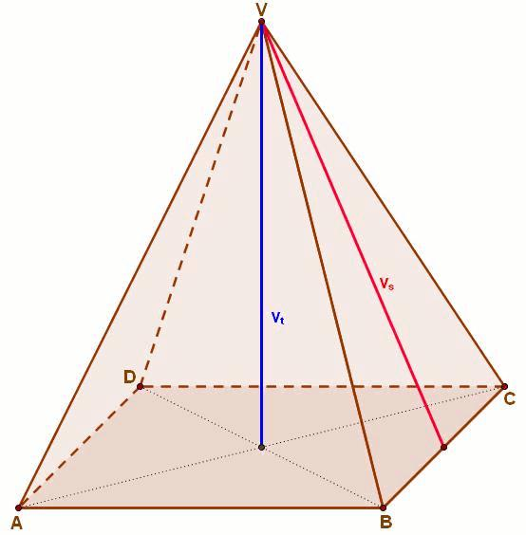
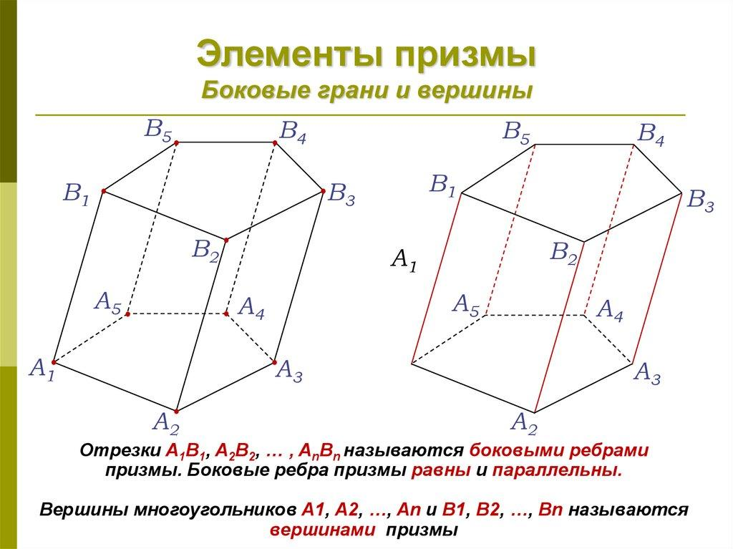
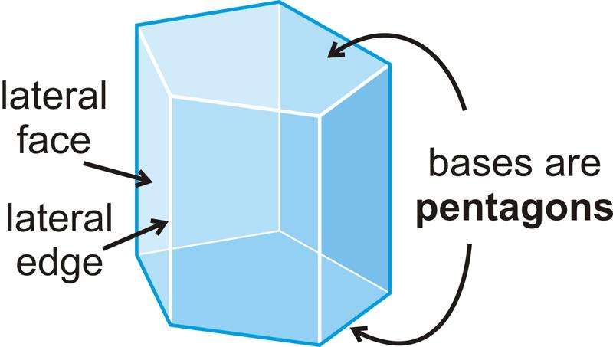

Definition
# Source: AI Source: Provided by: [Data Path: Persons Table -> ID Column: 1, Name_En Column: Motasem Essam] -> From: [ChatGPT] on [7/25/2026]
A lateral edge in solid geometry is an edge that connects vertices of a solid along its lateral structure, rather than lying along the boundary of its base.
The exact meaning depends on the type of solid:
- In a pyramid: a lateral edge connects the apex to a vertex of the base.
- In a prism: a lateral edge connects a vertex of one base to the corresponding vertex of the other base.
Lateral edges help form the side faces of a solid and determine how its base or bases connect to the rest of its structure.

Simple definition
# Source: AI Source: Provided by: [Data Path: Persons Table -> ID Column: 1, Name_En Column: Motasem Essam] -> From: [ChatGPT] on [7/25/2026]
A lateral edge is an edge that belongs to the side structure of a three-dimensional solid rather than to its base boundary.
Examples:
- A square pyramid has four lateral edges connecting its apex to the four vertices of its square base.
- A triangular prism has three lateral edges connecting corresponding vertices of its two triangular bases.
- A pentagonal pyramid has five lateral edges connecting its apex to the five vertices of its pentagonal base.

3. Classification tree
# Source: AI Source: Provided by: [Data Path: Persons Table -> ID Column: 1, Name_En Column: Motasem Essam] -> From: [ChatGPT] on [7/25/2026]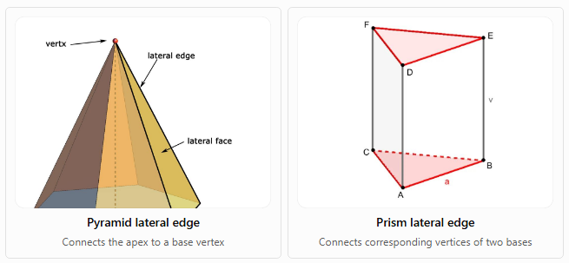
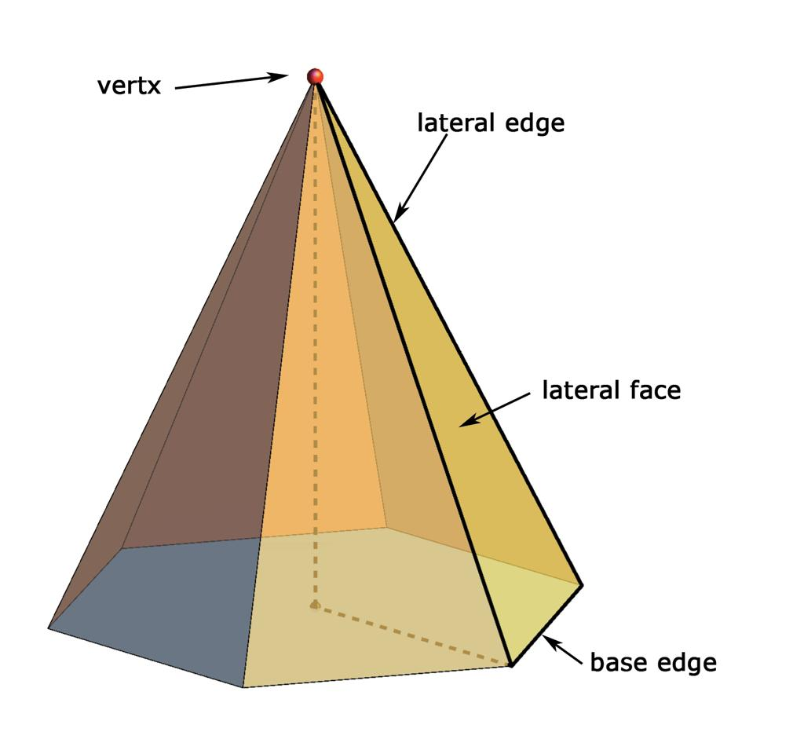
Pyramid lateral edge
Connects the apex to a base vertex
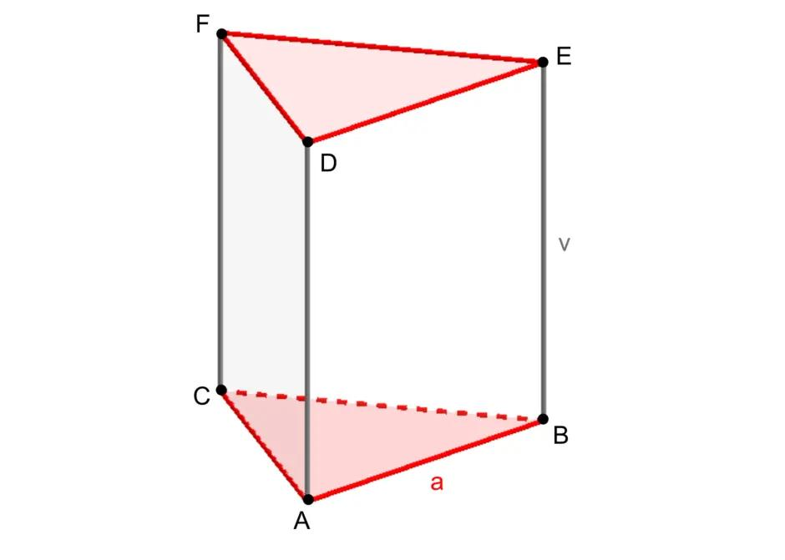
Prism lateral edge
Connects corresponding vertices of two bases
These are the two main uses of the term for common polyhedra.

Key characteristics
# Source: AI Source: Provided by: [Data Path: Persons Table -> ID Column: 1, Name_En Column: Motasem Essam] -> From: [ChatGPT] on [7/25/2026]
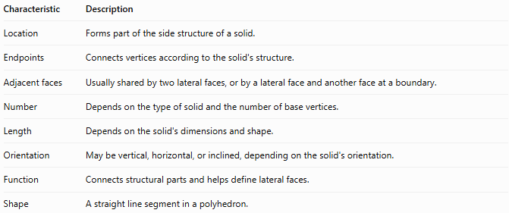
Characteristic | Description
Location | Forms part of the side structure of a solid.
Endpoints | Connects vertices according to the solid's structure.
Adjacent faces | Usually shared by two lateral faces, or by a lateral face and another face at a boundary.
Number | Depends on the type of solid and the number of base vertices.
Length | Depends on the solid's dimensions and shape.
Orientation | May be vertical, horizontal, or inclined, depending on the solid's orientation.
Function | Connects structural parts and helps define lateral faces.
Shape | A straight line segment in a polyhedron.

Geometric representation
# Source: AI Source: Provided by: [Data Path: Persons Table -> ID Column: 1, Name_En Column: Motasem Essam] -> From: [ChatGPT] on [7/25/2026]
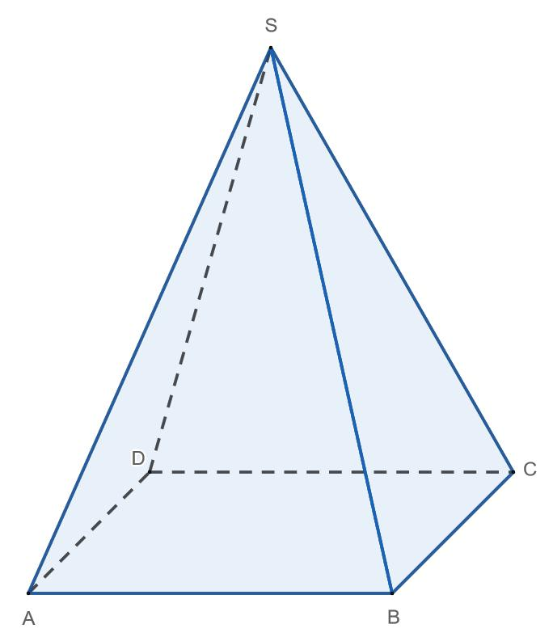
Consider a square pyramid with apex $S$ and base $ABCD$.
Its lateral edges are:
- $SA$
- $SB$
- $SC$
- $SD$
These edges connect the apex to the four base vertices.
The base edges are $AB$, $BC$, $CD$, and $DA$. They form the square base and are not lateral edges.
Lateral edges in different solids

A. Square pyramid
# Source: AI Source: Provided by: [Data Path: Persons Table -> ID Column: 1, Name_En Column: Motasem Essam] -> From: [ChatGPT] on [7/25/2026]
A square pyramid has four lateral edges, one from the apex to each vertex of its square base.
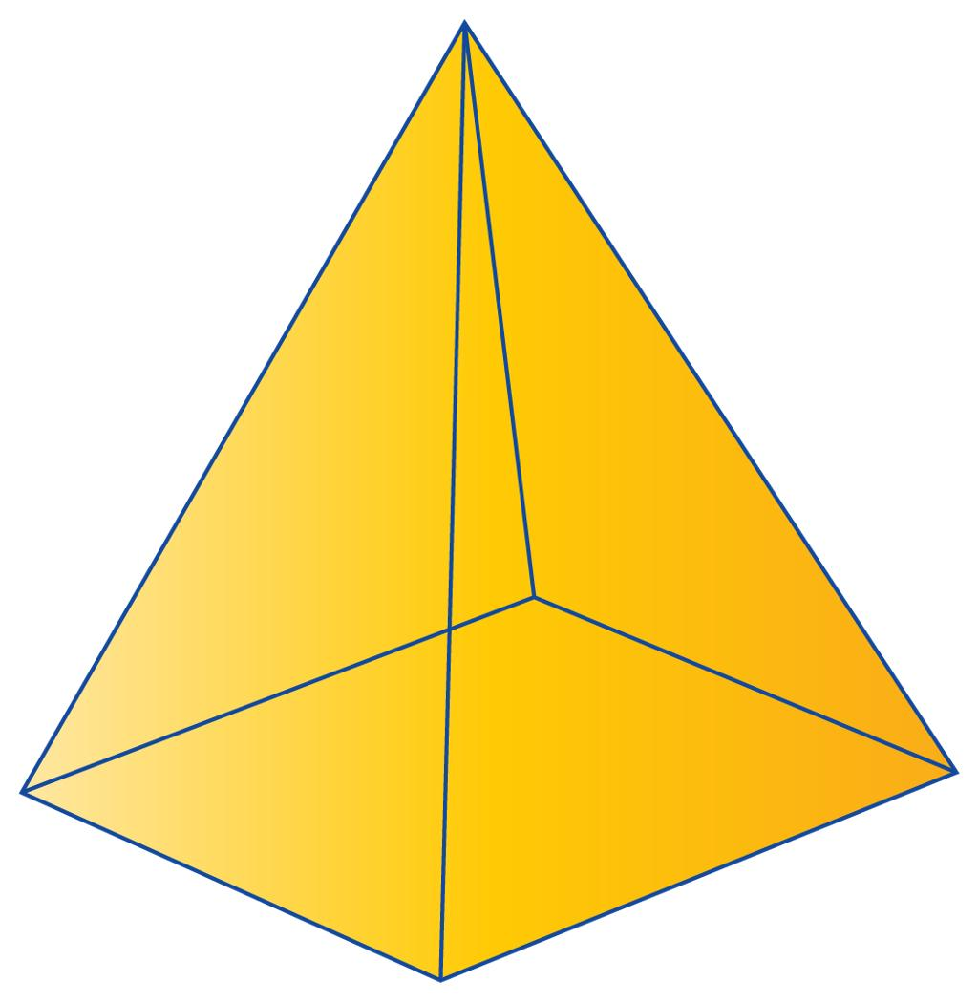

B. Triangular prism
# Source: AI Source: Provided by: [Data Path: Persons Table -> ID Column: 1, Name_En Column: Motasem Essam] -> From: [ChatGPT] on [7/25/2026]
A triangular prism has three lateral edges joining corresponding vertices of its two triangular bases.
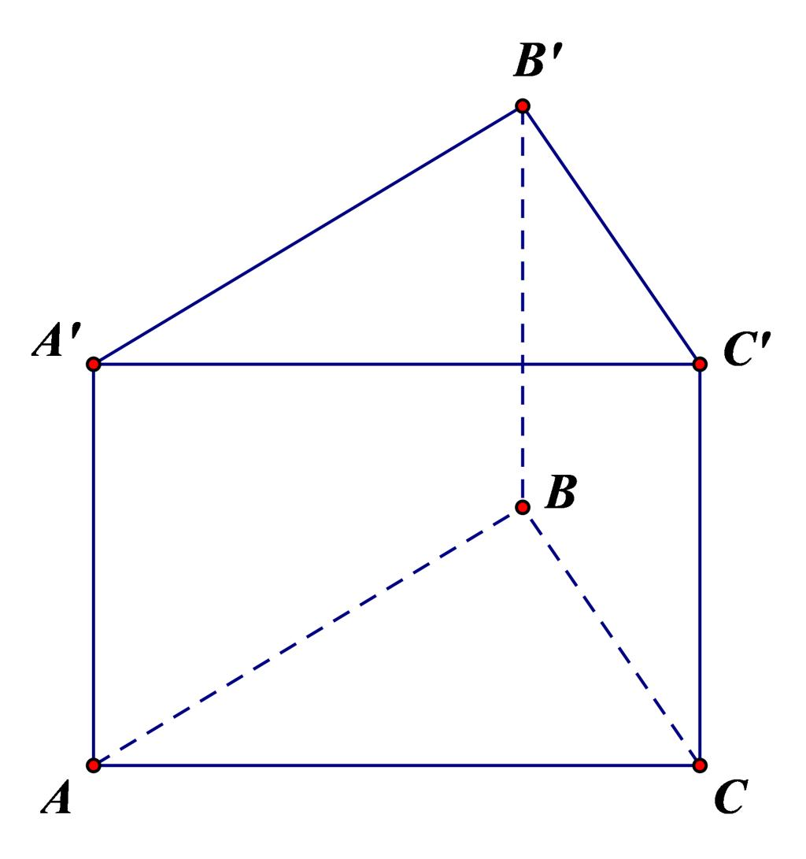

C. Pentagonal prism
# Source: AI Source: Provided by: [Data Path: Persons Table -> ID Column: 1, Name_En Column: Motasem Essam] -> From: [ChatGPT] on [7/25/2026]
A pentagonal prism has five lateral edges, each connecting a vertex on one base to the corresponding vertex on the other base.

6. Mathematical representations

A. Number of lateral edges in a pyramid
# Source: AI Source: Provided by: [Data Path: Persons Table -> ID Column: 1, Name_En Column: Motasem Essam] -> From: [ChatGPT] on [7/25/2026]
If a pyramid has a base polygon with $n$ vertices, each base vertex connects to the apex by one lateral edge.
$$\boxed{E_{\text{lateral}}=n}$$
where $n$ is the number of sides of the base polygon.

B. Number of lateral edges in a prism
# Source: AI Source: Provided by: [Data Path: Persons Table -> ID Column: 1, Name_En Column: Motasem Essam] -> From: [ChatGPT] on [7/25/2026]
If a prism has an $n$-sided base, each vertex on one base connects to one corresponding vertex on the other base.
$$\boxed{E_{\text{lateral}}=n}$$
Thus, both an $n$-sided pyramid and an $n$-sided prism have $n$ lateral edges, although the edges connect different parts of each solid.

C. Length of a lateral edge in a right prism
# Source: AI Source: Provided by: [Data Path: Persons Table -> ID Column: 1, Name_En Column: Motasem Essam] -> From: [ChatGPT] on [7/25/2026]
For a right prism, each lateral edge is perpendicular to the base planes. Its length equals the height $h$ of the prism:
$$\boxed{e_{\text{lateral}}=h}$$
This equality does not generally hold for an oblique prism, whose lateral edges may be inclined.

D. Length of a lateral edge in a regular pyramid
# Source: AI Source: Provided by: [Data Path: Persons Table -> ID Column: 1, Name_En Column: Motasem Essam] -> From: [ChatGPT] on [7/25/2026]
In a regular pyramid, the apex lies above the center of a regular polygonal base. Let:
- $h$ be the perpendicular height of the pyramid.
- $R$ be the circumradius of the base polygon.
- $l$ be the lateral-edge length.
By the Pythagorean theorem,
$$\boxed{l=\sqrt{h^{2}+R^{2}}}$$
This formula applies to a regular right pyramid.

Worked examples
# Source: AI Source: Provided by: [Data Path: Persons Table -> ID Column: 1, Name_En Column: Motasem Essam] -> From: [ChatGPT] on [7/25/2026]
Example 1: Lateral edges of a hexagonal pyramid
A hexagonal pyramid has a base with six sides. How many lateral edges does it have?
Step 1: Count the base vertices.
$$n=6$$
Step 2: Apply the pyramid formula.
$$E_{\text{lateral}}=n=6$$
Answer: The hexagonal pyramid has 6 lateral edges.
Example 2: Lateral edges of an octagonal prism
An octagonal prism has two octagonal bases. Determine the number of lateral edges.
An octagon has eight vertices, and each vertex on one base connects to a corresponding vertex on the other base.
$$E_{\text{lateral}}=n=8$$
Answer: The octagonal prism has 8 lateral edges.
Example 3: Finding a lateral-edge length
A regular square pyramid has a perpendicular height of $12\text{ cm}$. Its square base has side length $10\text{ cm}$. Find the length of a lateral edge.
Step 1: Find the circumradius of the square base.
The distance from the center of a square to a vertex is half its diagonal.
$$R=\frac{10\sqrt{2}}{2}=5\sqrt{2}\text{ cm}$$
Step 2: Apply the Pythagorean theorem.
$$\begin{aligned}l&=\sqrt{h^{2}+R^{2}} \\ &=\sqrt{{12}^{2}+{\left(5\sqrt{2}\right)}^{2}} \\ &=\sqrt{144+50} \\ &=\sqrt{194}\text{ cm}\end{aligned}$$
Answer:
$$\boxed{l=\sqrt{194}\text{ cm}≈13.93\text{ cm}}$$

Comparison with related edge types
# Source: AI Source: Provided by: [Data Path: Persons Table -> ID Column: 1, Name_En Column: Motasem Essam] -> From: [ChatGPT] on [7/25/2026]
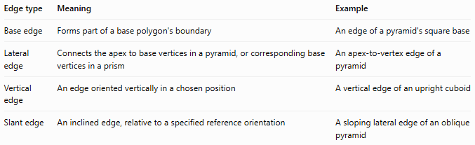
Edge type | Meaning | Example
Base edge | Forms part of a base polygon's boundary | An edge of a pyramid's square base
Lateral edge | Connects the apex to base vertices in a pyramid, or corresponding base vertices in a prism | An apex-to-vertex edge of a pyramid
Vertical edge | An edge oriented vertically in a chosen position | A vertical edge of an upright cuboid
Slant edge | An inclined edge, relative to a specified reference orientation | A sloping lateral edge of an oblique pyramid
Important: A lateral edge is identified by its structural role, not simply by its direction. A lateral edge may be vertical or inclined, depending on the solid and how it is positioned.

Applications
# Source: AI Source: Provided by: [Data Path: Persons Table -> ID Column: 1, Name_En Column: Motasem Essam] -> From: [ChatGPT] on [7/25/2026]
Lateral edges are useful in:
- Geometry calculations: counting edges and determining side-face dimensions.
- Architecture: describing the sloping structural members of pyramid-shaped roofs.
- Engineering: defining the connections between bases in prismatic structures.
- 3D modeling: connecting vertices to build polygonal surfaces.
- Measurement: calculating edge lengths using heights and other dimensions.
- Spatial reasoning: distinguishing base structure from lateral structure.

Key points
# Source: AI Source: Provided by: [Data Path: Persons Table -> ID Column: 1, Name_En Column: Motasem Essam] -> From: [ChatGPT] on [7/25/2026]
- A lateral edge belongs to the side structure of a solid.
- In a pyramid, it connects the apex to a base vertex.
- In a prism, it connects corresponding vertices of the two bases.
- A pyramid or prism with an \(n\)-sided base has \(n\) lateral edges.
- In a right prism, lateral-edge length equals the perpendicular height.
- Lateral edges are distinct from base edges, which form the boundary of a base polygon.

Conclusion
# Source: AI Source: Provided by: [Data Path: Persons Table -> ID Column: 1, Name_En Column: Motasem Essam] -> From: [ChatGPT] on [7/25/2026]
A lateral edge in solid geometry is an edge that connects important vertices along the side structure of a solid. Its exact role depends on whether the solid is a pyramid, prism, or another polyhedron. Identifying lateral edges helps with counting edges, understanding side faces, and calculating geometric dimensions.

